Introduction to Data Science



Slide 1: Title Slide

Slide 2: What is Data Science?

- Define Data Science and its importance in today's world.

- Explain how Data Science combines various disciplines like statistics, machine learning, and domain expertise.

Slide 3: Data Science Process

- Introduce the Data Science process, including data collection, data cleaning, data exploration, modeling, evaluation, and deployment.

- Highlight the iterative nature of the process.

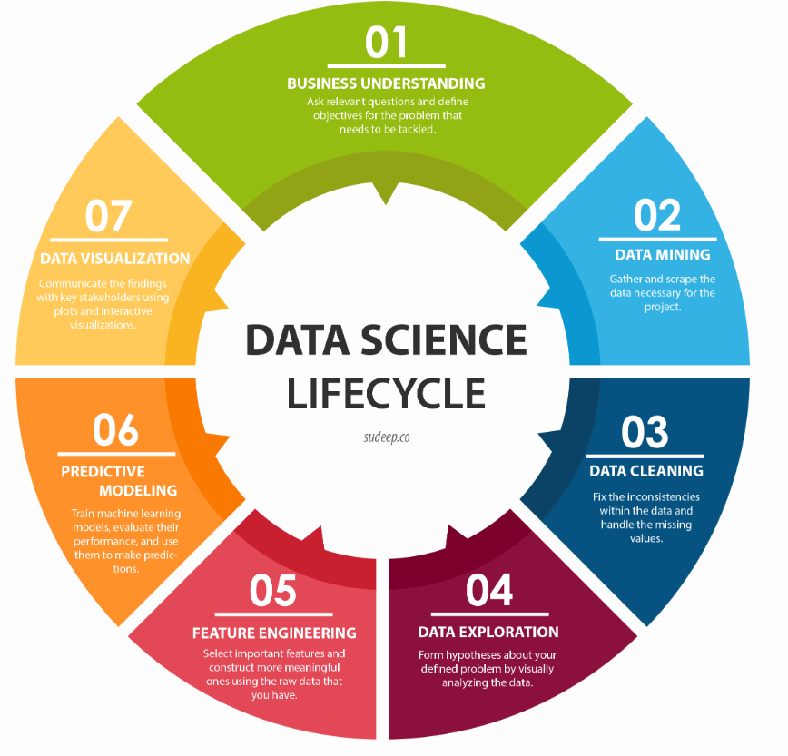

Slide 4: Data Collection and Preprocessing

- Discuss the various sources of data and challenges in data collection.

- Explain the importance of data preprocessing to clean and prepare data for analysis.

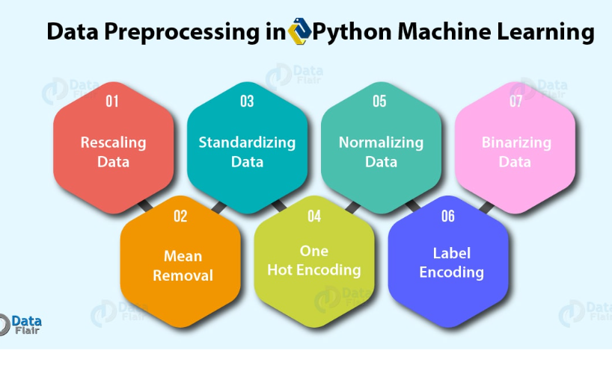

Slide 5: Exploratory Data Analysis (EDA)

- Describe the process of EDA to gain insights from data.

- Showcase some common data visualization techniques used in EDA.

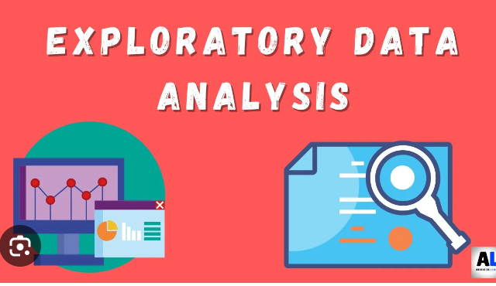

Slide 6: Machine Learning Algorithms

- Introduce popular machine learning algorithms such as linear regression, decision trees, random forests, support vector machines, and neural networks.

- Briefly explain how these algorithms work.

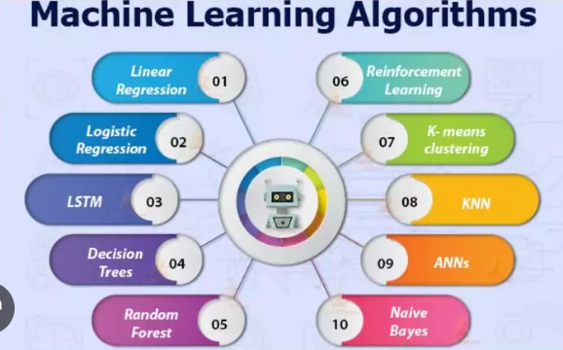

Slide 7: Model Evaluation and Selection

- Explain different evaluation metrics used to assess the performance of machine learning models.

- Discuss the importance of cross-validation and hyperparameter tuning.



Slide 8: Data Science Tools and Libraries

- Mention some widely used Data Science tools and libraries like Python, R, TensorFlow, scikit-learn, and pandas.

- Highlight their capabilities and advantages.

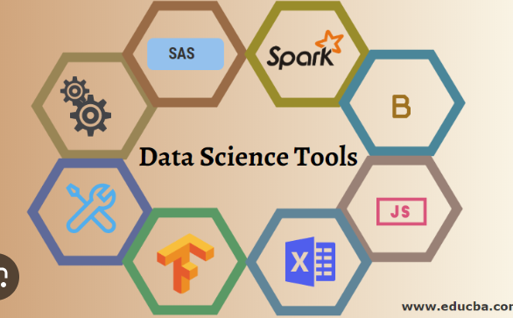

Slide 9: Real-Life Data Science Applications

- Provide examples of Data Science applications in different industries, such as healthcare, finance, e-commerce, and marketing.

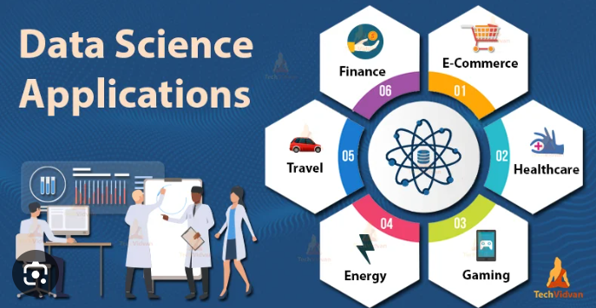

Do you know? Data Science is of huge importance in the E-commerce industry.

Data Science applications help enterprises for making predictions about **profit**, **loss**, and **sales**.

Companies also use Data Science for influencing customers. So that the customers buy their products by using the customers’ data for evaluating their needs and interests.



Slide 10: Ethical Considerations

- Discuss the ethical implications of Data Science, including privacy concerns and biases in data.



Slide 11: Challenges in Data Science

- Highlight some challenges faced by Data Scientists, like dealing with big data, data quality issues, and interpretability of complex models.

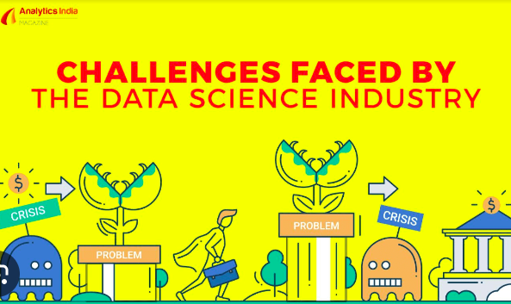

Slide 12: Future of Data Science

- Talk about emerging trends and advancements in Data Science, such as AI explainability, federated learning, and automated machine learning.

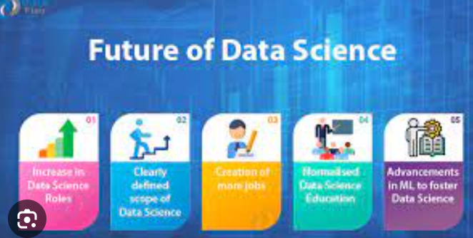

Slide 13: Conclusion

- Summarize the key points of the presentation.

- Encourage further exploration and learning in Data Science.

Slide 14: Q&A

- Reserve a slide for the audience to ask questions and engage in discussions.

Slide 15: Thank You

- End the presentation with a "Thank You" slide and your contact information for further inquiries.

More Details………….

Q6.

can you give details of "Talk about emerging trends and advancements in Data Science, such as AI explainability, federated learning, and automated machine learning"?

Ans::

Certainly! Here are some emerging trends and advancements in Data Science:

1. AI Explainability:

As artificial intelligence (AI) and machine learning models become more complex, there is a growing need for AI explainability. AI explainability refers to the ability to understand and interpret the decisions made by AI models. Black-box models, such as deep neural networks, often lack transparency, making it challenging to explain why a certain decision was reached. Explainable AI techniques aim to provide insights into model predictions, increasing trust and allowing stakeholders to understand the underlying factors driving the decisions.

2. Federated Learning:

Federated learning is a decentralized approach to machine learning, where models are trained across multiple devices or servers without sharing raw data centrally. In federated learning, data remains on the edge devices, and only model updates are shared with a central server. This approach ensures data privacy and security, as sensitive information is not exposed during model training. Federated learning is particularly useful in scenarios where data is distributed across different locations or devices, such as in IoT devices or mobile applications.

3. Automated Machine Learning (AutoML):

Automated Machine Learning, or AutoML, aims to automate the end-to-end process of applying machine learning to real-world problems. AutoML platforms streamline tasks such as data preprocessing, feature selection, hyperparameter tuning, and model selection, making it easier for non-experts to build and deploy machine learning models. AutoML reduces the manual effort and expertise required, democratizing access to machine learning and accelerating model development.

4. Natural Language Processing (NLP) Advancements:

Advancements in Natural Language Processing have fueled breakthroughs in language understanding, sentiment analysis, machine translation, and chatbots. Pre-trained language models, such as BERT (Bidirectional Encoder Representations from Transformers), have shown remarkable performance in a wide range of NLP tasks. NLP models are now capable of understanding context, semantics, and even generating human-like language.

5. Graph Neural Networks (GNNs):

Graph Neural Networks are gaining traction for their ability to analyze and model data with complex relationships, such as social networks, recommendation systems, and molecular structures. GNNs leverage graph structures to capture dependencies between data points, enabling more accurate predictions and representations.

6. Responsible AI and Ethical Considerations:

As AI and Data Science technologies become more pervasive, there is an increasing emphasis on responsible AI practices. Ethical considerations, bias mitigation, fairness, and transparency in AI systems are gaining attention. Data Scientists are focusing on developing models that are not only accurate but also adhere to ethical principles and societal norms.

7. Edge Computing and IoT Integration:

Data Science is moving towards edge computing and integrating with the Internet of Things (IoT) to process data closer to the source. Edge computing reduces latency, conserves bandwidth, and enables real-time analysis of IoT-generated data. Data Scientists are exploring ways to optimize models for edge devices and develop distributed learning approaches for IoT environments.

These emerging trends and advancements in Data Science are driving innovation and opening new possibilities for applications in various domains. As the field continues to evolve, staying informed about these trends and leveraging the latest tools and techniques can lead to more impactful and successful Data Science projects.

Q5.

can you give details of "Highlight some challenges faced by Data Scientists, like dealing with big data, data quality issues, and interpretability of complex models."?

Ans:

Data Scientists face several challenges in their work, and here are some of the key ones:

1. Dealing with Big Data:

The increasing volume, velocity, and variety of data have led to the emergence of big data challenges. Data Scientists often work with massive datasets that may not fit into conventional memory and require distributed processing frameworks like Hadoop or Spark. Processing and analyzing big data efficiently can be time-consuming and resource-intensive.

2. Data Quality Issues:

Data quality is crucial for accurate and reliable analysis. Data Scientists often encounter data that is incomplete, inconsistent, or contains errors. Cleaning and preprocessing data to handle missing values, outliers, and noise are essential steps, but it can be a time-consuming process that impacts the overall analysis.

3. Interpretability of Complex Models:

Complex machine learning models, such as deep neural networks, can achieve high predictive accuracy but are often considered "black boxes" due to their intricate internal workings. Interpreting these models and understanding the factors that drive their predictions can be challenging. In some applications, interpretability is critical for gaining trust and insights from the model's decisions.

4. Data Privacy and Security:

Data Scientists must navigate the ethical and legal considerations related to data privacy and security. Working with sensitive or personally identifiable information requires strict adherence to data protection regulations and best practices to ensure data is handled securely.

5. Model Overfitting:

Overfitting occurs when a model performs well on the training data but poorly on new, unseen data. Data Scientists need to strike a balance between model complexity and generalization to avoid overfitting and ensure the model's effectiveness on real-world data.

6. Data Bias and Fairness:

Data bias can lead to unfair and discriminatory outcomes in machine learning models. Data Scientists need to be mindful of biased data and work to mitigate bias in model training to ensure fair and equitable decision-making.

7. Model Deployment and Integration:

Deploying machine learning models into production systems can be complex, especially when integrating with existing software or infrastructure. Operational challenges such as model versioning, scalability, and monitoring need to be addressed for successful deployment.

8. Continuous Learning and Rapid Technological Advancements:

The field of Data Science is constantly evolving, with new algorithms, tools, and techniques being developed regularly. Data Scientists need to stay updated with the latest advancements and continuously improve their skills to stay relevant in the rapidly changing landscape.

Despite these challenges, Data Scientists play a crucial role in extracting valuable insights from data and driving data-driven decision-making across industries. By overcoming these challenges, Data Scientists contribute to the development of innovative solutions, improved business strategies, and better understanding of complex phenomena.

Q4. can you give details of " examples of Data Science applications in different industries, such as healthcare, finance, e-commerce, and marketing."

Ans:

Data Science has made a significant impact in various industries, transforming how businesses operate and make decisions. Here are some examples of Data Science applications in different industries:

1. Healthcare:

- Disease Diagnosis: Data Science is used to analyze patient data, medical images, and genetic information to assist in the early detection and diagnosis of diseases like cancer, diabetes, and heart conditions.

- Drug Discovery: Data Science helps pharmaceutical companies analyze vast amounts of molecular and clinical data to identify potential drug candidates and accelerate the drug discovery process.

- Predictive Analytics: Data-driven models are utilized to predict patient outcomes, readmission rates, and potential disease outbreaks, aiding in healthcare resource planning and improving patient care.

2. Finance:

- Credit Risk Assessment: Financial institutions use Data Science to analyze customer data and credit history to assess credit risk and make informed lending decisions.

- Fraud Detection: Data Science algorithms detect fraudulent transactions by analyzing patterns and anomalies in large volumes of financial data, helping prevent financial losses.

- Algorithmic Trading: Data Science enables the development of trading algorithms that use historical and real-time market data to make automated and optimized trading decisions.

3. E-commerce:

- Recommender Systems: Data Science is employed to build personalized recommendation engines that suggest products, services, or content based on user behavior and preferences, enhancing user experience and driving sales.

- Customer Segmentation: Data Science helps e-commerce businesses segment customers into groups based on behavior, demographics, and purchase history, enabling targeted marketing and personalized promotions.

- Price Optimization: Data Science algorithms are used to set dynamic pricing strategies based on factors like demand, competition, and customer behavior to maximize revenue.

4. Marketing:

- Customer Churn Prediction: Data Science models analyze customer data to predict churn and identify factors that influence customer retention, allowing businesses to implement targeted retention strategies.

- Sentiment Analysis: Data Science is used to analyze customer feedback, social media data, and reviews to understand customer sentiment and improve brand reputation and customer satisfaction.

- A/B Testing: Data Science helps marketers conduct controlled experiments to compare the effectiveness of different marketing strategies and optimize campaigns.

These are just a few examples, and Data Science continues to drive innovation and efficiency across various industries. From personalized healthcare treatments to enhanced customer experiences and optimized business operations, the applications of Data Science are diverse and continuously evolving. As organizations generate and accumulate more data, the role of Data Science in driving informed decision-making and business growth becomes even more critical.

Q3.

can you give details of " popular machine learning algorithms such as linear regression, decision trees, random forests, support vector machines, and neural networks"?

Ans:

Sure! Here are details of popular machine learning algorithms:

1. Linear Regression:

Linear regression is a simple and widely used algorithm for supervised learning, particularly in regression tasks. It models the relationship between a dependent variable (target) and one or more independent variables (features) as a linear equation. The goal of linear regression is to find the best-fitting line (or hyperplane in higher dimensions) that minimizes the sum of the squared differences between the actual and predicted values. Linear regression is suitable for continuous numerical predictions.

2. Decision Trees:

Decision trees are versatile and interpretable machine learning algorithms used for both classification and regression tasks. They partition the data into hierarchical structures of nodes, where each node represents a feature and each branch corresponds to a decision based on that feature. Decision trees make predictions by traversing from the root node to the leaf nodes, where each leaf node represents a class label or a regression value. Decision trees are easy to understand and visualize, making them useful for interpretability.

3. Random Forests:

Random Forests are an ensemble learning method that combines multiple decision trees to improve predictive performance and reduce overfitting. Each tree in the forest is trained on a random subset of the data and features, and the final prediction is obtained by aggregating the predictions of individual trees. Random Forests are robust, handle high-dimensional data well, and provide feature importance rankings.

4. Support Vector Machines (SVM):

SVM is a powerful algorithm used for both classification and regression tasks. It works by finding the optimal hyperplane that best separates data points of different classes in a high-dimensional space. SVM aims to maximize the margin between classes while minimizing classification errors. SVM is effective for binary classification tasks and can be extended to handle multi-class problems as well.

5. Neural Networks:

Neural Networks, particularly deep learning models, have gained significant popularity due to their ability to handle complex and large-scale data. These models are inspired by the human brain's neural structure and consist of interconnected layers of artificial neurons. Deep learning architectures, such as Convolutional Neural Networks (CNNs) for image recognition and Recurrent Neural Networks (RNNs) for sequential data, have achieved state-of-the-art performance in various tasks like image recognition, natural language processing, and speech recognition.

Each of these machine learning algorithms has its strengths and weaknesses, and their performance depends on the nature of the data and the problem at hand. Data Scientists often experiment with different algorithms and tune their hyperparameters to achieve the best results for a specific task. Additionally, ensemble techniques, like combining different models, are commonly used to further enhance predictive accuracy and robustness.

Q2. "Data Science process, including data collection, data cleaning, data exploration, modeling, evaluation, and deployment." ?

Ans::

The Data Science process is a systematic and iterative approach to extract knowledge and insights from data. It involves several stages, each with its unique objectives and techniques. Here's a detailed explanation of each stage in the Data Science process:

1. Data Collection:

Data collection is the first step in the Data Science process. It involves gathering relevant data from various sources. The data can be structured (e.g., databases, spreadsheets) or unstructured (e.g., text, images). The main objectives of data collection are to ensure that the data is comprehensive, representative, and relevant to the problem at hand. Data can be collected from internal databases, web scraping, APIs, surveys, and other sources.

2. Data Cleaning:

Data collected from different sources may have inconsistencies, missing values, and errors. Data cleaning, also known as data preprocessing, is the process of addressing these issues to ensure the data is of high quality and ready for analysis. Data cleaning techniques include removing duplicates, handling missing values, smoothing noisy data, and standardizing data formats.

3. Data Exploration:

Data exploration involves understanding the structure and characteristics of the data. Data Scientists use descriptive statistics, data visualization, and exploratory data analysis (EDA) techniques to gain insights into the data. Visualization tools such as histograms, scatter plots, and heatmaps help identify patterns, trends, and relationships within the data.

4. Modeling:

In the modeling stage, Data Scientists apply various machine learning algorithms and statistical models to the preprocessed data to build predictive or descriptive models. The choice of the model depends on the problem type (classification, regression, clustering, etc.) and the nature of the data. Common modeling techniques include linear regression, decision trees, random forests, support vector machines, and neural networks.

5. Evaluation:

After building the models, they need to be evaluated to determine their performance and accuracy. Evaluation metrics such as accuracy, precision, recall, F1-score, and ROC-AUC are used to assess the model's effectiveness. Data Scientists may use techniques like cross-validation to ensure the model generalizes well to new, unseen data.

6. Deployment:

Once a satisfactory model is developed and evaluated, it needs to be deployed to make it accessible for use. Deployment can involve integrating the model into existing software systems, creating APIs for real-time predictions, or building web applications. Continuous monitoring and updates may be required to ensure the model's performance remains optimal over time.

7. Interpretation and Communication:

The final stage involves interpreting the results of the analysis and communicating the findings to stakeholders. Data Scientists need to present their insights and recommendations in a clear and understandable manner to non-technical audiences. Visualization and storytelling techniques are often used to communicate complex results effectively.

It's important to note that the Data Science process is iterative, meaning that Data Scientists may need to revisit previous stages based on the results and feedback. The process is flexible and adaptive, allowing for continuous improvement and refinement of the models and analyses.

Q1. "**how Data Science combines various disciplines like statistics, machine learning, and domain expertise"?**

Ans:-

Data Science is an interdisciplinary field that combines various disciplines to extract knowledge and insights from data. Here's a detailed explanation of how Data Science integrates statistics, machine learning, and domain expertise:

1. Statistics:

Statistics is a fundamental component of Data Science. It involves the collection, analysis, interpretation, presentation, and organization of data. Data Scientists use statistical methods to understand the underlying patterns and trends in the data. Key statistical techniques used in Data Science include:

- Descriptive Statistics: Summarizing and describing the main features of data using measures like mean, median, mode, variance, and standard deviation.

- Inferential Statistics: Drawing conclusions and making predictions about a population based on a sample of data.

- Hypothesis Testing: Testing hypotheses and determining the significance of observed differences or relationships.

- Regression Analysis: Modeling the relationship between variables and making predictions.

Statistics helps Data Scientists gain insights into the data and make data-driven decisions.

2. Machine Learning:

Machine Learning is a subset of artificial intelligence that enables systems to learn from data without being explicitly programmed. It allows computers to identify patterns, make predictions, and improve performance based on experience. In Data Science, Machine Learning techniques are used for:

- Predictive Modeling: Building models to predict outcomes or target variables based on input features.

- Clustering: Grouping similar data points into clusters based on their characteristics.

- Classification: Assigning data points to predefined categories or classes.

- Recommender Systems: Suggesting relevant products or content to users based on their preferences.

- Anomaly Detection: Identifying unusual or rare events in the data.

Machine Learning algorithms leverage statistical methods and large-scale computational power to process vast amounts of data and make accurate predictions.

3. Domain Expertise:

Domain expertise refers to specialized knowledge and understanding of a specific industry or subject area. In Data Science, domain experts play a crucial role in:

- Defining the problem: Domain experts work closely with Data Scientists to articulate the business problem and the objectives of the analysis.

- Feature Engineering: Domain experts help identify relevant features or variables that are important for modeling.

- Interpreting results: Domain experts interpret the output of Data Science models in the context of the domain, providing valuable insights and actionable recommendations.

- Ensuring meaningful outcomes: Domain expertise ensures that the results of the analysis align with real-world implications and requirements.

By combining domain expertise with statistical knowledge and machine learning techniques, Data Scientists can develop solutions that are tailored to specific business needs and add significant value to organizations.

In summary, Data Science brings together statistics, machine learning, and domain expertise to extract valuable insights from data and solve complex problems across various industries and domains. The synergy between these disciplines enables Data Scientists to make informed decisions, optimize processes, and drive innovation.

Basic outline and guidance for a Data Science project using Spring Boot/Java technology.

Data Science projects are usually complex and require significant effort and domain expertise.

Here's an outline of the project that you can use as a starting point:

**Project Title**: Data Science Project with Spring Boot/Java

**Objective**: Build a Data Science application using Spring Boot/Java that analyzes a dataset and provides useful insights and visualizations.

Steps:

1. **Data Collection**: Gather the dataset that you want to analyze. It could be in CSV, Excel, or any other format.

e.g. "Data Collection: " using H2 database

Please note that this is a simplified example for demonstrating data collection using H2. In a real application, you might have more complex data models and additional logic for data processing and analysis.

2. **Data Preprocessing**: Clean and preprocess the data to handle missing values, outliers, and any other data inconsistencies.

e.g. we use the Stanford CoreNLP library to perform the stemming process. Make sure to include the Stanford CoreNLP library in your project dependencies for this code to work correctly.

Please note that this example covers basic data preprocessing techniques. Depending on your specific use case and requirements, you may need to incorporate additional data cleaning and preprocessing step

3. **Data Analysis**: Implement various Data Science techniques using Java libraries like Apache Spark, Weka, or other relevant tools to analyze the dataset. Examples of analysis tasks could include data summarization, statistical analysis, or machine learning algorithms.

e.g. The sentiment is classified into five categories: "Very negative," "Negative," "Neutral," "Positive," and "Very positive."

Please note that this example demonstrates basic sentiment analysis using the Stanford NLP library. For more accurate and advanced sentiment analysis, you may need to train the model on a labeled dataset of positive and negative reviews. Additionally, you can explore other NLP libraries like Apache OpenNLP or implement more sophisticated Machine Learning algorithms to improve the accuracy of sentiment analysis

4. **Visualization**: Utilize Java libraries like JFreeChart or JavaFX to create visualizations that help in understanding the data patterns and insights.

5. **Create a Spring Boot Application**: Set up a Spring Boot project and create necessary REST endpoints to interact with the data and retrieve insights or visualizations.

6. **Frontend Integration:** Build a simple frontend using HTML, CSS, and JavaScript to interact with the Spring Boot backend and display the results.

7. **Deployment**: Deploy the Spring Boot application on a server or cloud platform for easy access.

Remember that a complete Data Science project would require you to handle various challenges, like selecting the right **algorithms**, tuning **hyperparameters**, and interpreting the results. It's important to have a strong understanding of Data Science concepts and Java programming to undertake such a project.

For complex Data Science tasks, you might consider using **Python** along with libraries **like Pandas, NumPy, and scikit-learn**, as Python is more commonly used in the Data Science community due to its extensive libraries and frameworks specific to the field.